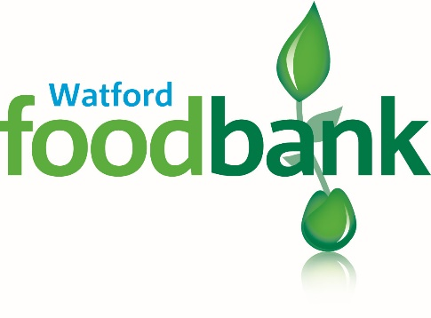
Data Privacy Statement
The foodbank keeps data about clients in a secure database.
This means the data from your foodbank voucher. Sometimes there may be some extra notes, and we might keep other information which we need in order to give you extra help.
We keep your data as secure as possible.
We never give or sell data to any other body.
We need the data from foodbank vouchers in order to check how many times people come to the foodbank, and to be able to give reports about the need for foodbanks.
Under data protection legislation, we must have a “lawful basis” for holding your data. Our “lawful basis” for holding your voucher data is called “legitimate interest”. This is because it is reasonable for us to have your data, in order for the foodbank to operate as expected.
Under data protection legislation, you have several rights:
- A right to know what data we hold about you
- A right to have a copy of the data we hold about you
- A right to have errors in your data corrected
- A right to object to us holding your data, or using it
- A right for your data to be deleted, if we keep it longer than needed

If you would like to know more about your data and your rights, please request a full “data privacy statement” at info@watford.foodbank.org.uk.

