
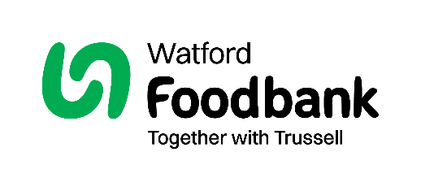
Data protection
Watford Foodbank is committed to protecting your privacy and will process your personal data in accordance with the General Data Protection Act 2018. XXXXXX Foodbank collects information to keep in touch with you and supply you with information relating to our work. This includes informing you of fundraising that might be of interest to you. Watford Foodbank will never sell or pass your details to anyone who isn’t directly working on our behalf.

To change your communication preferences at any time, please call us on 01923 804435 (Monday to Friday, 10am to 1pm)
or email info@watford.foodbank.org.uk.

We would love to know why you have chosen to donate to Watford Foodbank. If you would like to share your motivation you can write it here:

We would love to be able to send you updates with information about our work, fundraising activities and ways to get involved.
Let us know below how you prefer to be contacted by us:
Gift aid form
By filling in this form we’ll receive an extra 25p for every £1 you give at no extra cost to you. Thank you!

Telephone
Mobile
No, please do not contact me via post
Email

Your details
If you are a UK tax payer, we can reclaim 25p for every £1 you give, that is an extra 25% on top of your gift!

Date:

Let us know how you would like to be contacted in the future
Email:
Phone:
Postcode:

Address:
Title:
Name:
I want to Gift Aid my donation, and any donations I make in the future or have made in the past four years, to Watford Foodbank.
I am a UK taxpayer and understand that if I pay less Income Tax and/or Capital Gains Tax than the amount of Gift Aid claimed on all my donations in that tax year it is my responsibility to pay any difference.

Registered charity number (1184482). Registered in England and Wales.
Sending in your Gift Aid form
Please send the completed form to: Unit 5, Empire Centre, Imperial Way, Watford, WD24 4YH

