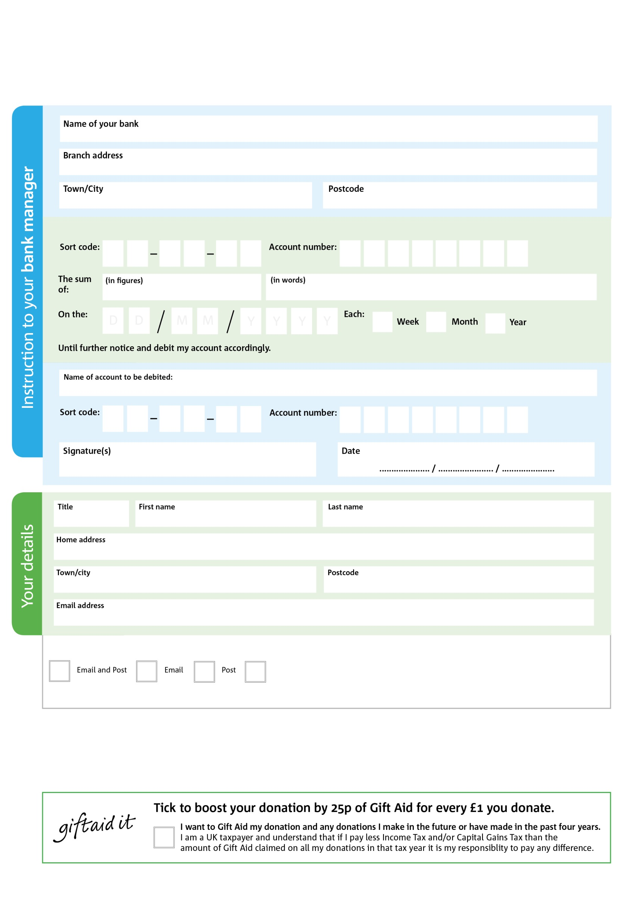

POSTAL ADDRESS: Watford Foodbank, Unit 5 The Empire Centre, Imperial Way,Watford, WD24 4YH

Reg. Charity No: 1184482 | Reg. in England & Wales
3X

V
2

V
1X

V
8

V
1

V
2

V
7

V
6

V
Please pass this form onto the foodbank, using the foodbank’s address at the bottom, who will save a copy for their records.
They will then send it onto your named bank or building society.

9

9

2

9

8

0

We would love to keep you up to date with information about Watford Foodbank. Please tick your preference:

You can change your preferences any time by contacting us on 01923 804435 or emailing us at info@watford.foodbank.org.uk

I do not wish to receive future communications from Watford Foodbank

Please pay WATFORD FOODBANK

Data protection
'Watford Foodbank is committed to protecting your privacy and will process your personal data in accordance with current Data Protection legislation. Watford Foodbank collects information to keep in touch with you and supply you with information relating to our work. To unsubscribe, send a message to the email address above with the word unsubscribe in the subject line. A full data privacy statement for financial donors is available from the foodbank on request.’

Standing Order Mandate
watford.foodbank.org.uk

You can change your preferences any time by contacting us on XXXXXXXXXXX or emailing us at XXXX@XXXXXXXXXX.foodbank.org.uk

I do not wish to receive future communications from XXXXXX Foodbank

